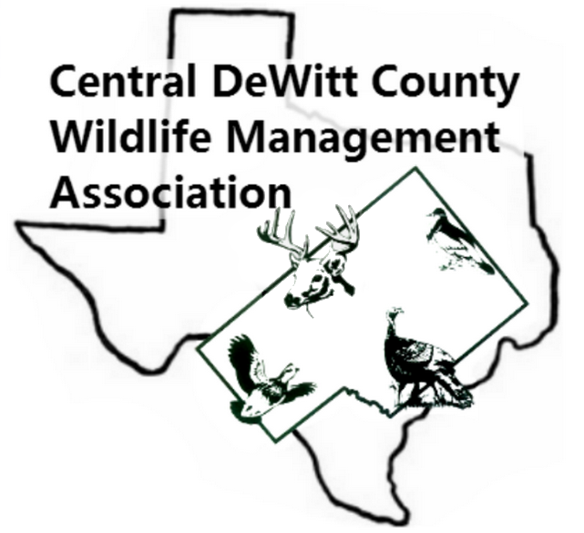Central DeWitt County Wildlife Management Association
Scholarship Application

General Information

Name: _________________________________________________________________________________________

Address: ______________________________________________________________________________________

Phone Number: _________________________ E-mail Address:__________________________________

Name of Sponsor (parent, grandparent) __________________________________________________

Please attach photo.

Wildlife Interest

List, by year, the CDCWMA contests you have entered.

- _________________________________________________________________________________________
- _________________________________________________________________________________________
- _________________________________________________________________________________________
- _________________________________________________________________________________________
- ________________________________________________________________________________________
To what / whom do you credit your interest in Wildlife Management? ________________
__________________________________________________________________________________________________________________________________________________________________________________________________
Attach a brief paragraph (not to exceed 100 words) as to why you feel wildlife and nature management in DeWitt County is important.

Academic Information

Name of Academic / Training Institution(s) to which you have applied. _______________
_________________________________________________________________________________________________

Chosen field of Study (Does not have to be wildlife related in order to be awarded a scholarship). _________________________________________________________________________________

Applications must be mailed to CDCWMA, PO Box 776, Cuero, Tx 77954 or E-mailed to cdcwma@gmail.com with postmark / E-mail date NLT May 1st.

